|  |  |
| --- | --- |
|  |  |

**EXERCISE 1**

**AIM**: Create the following table.

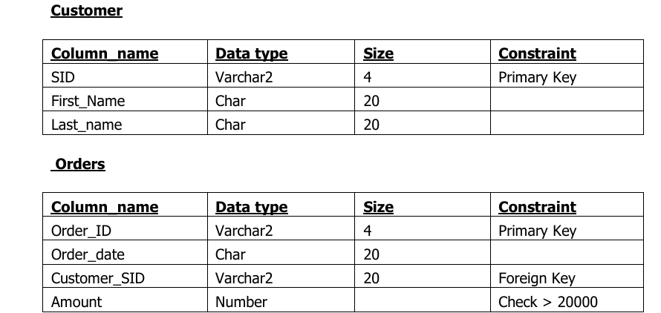

**Output:**

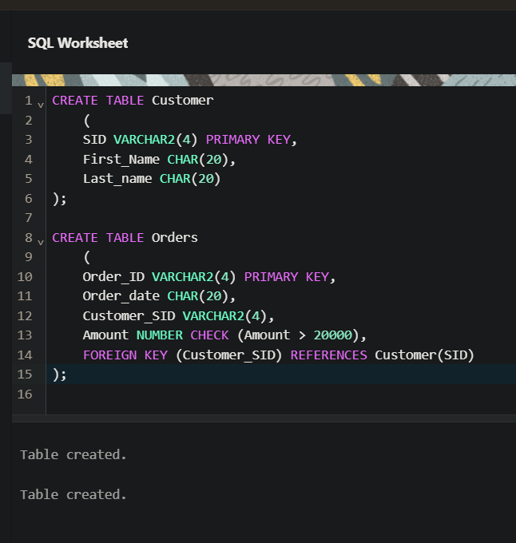

**EXERCISE 2**

**AIM:** Insert 5 records for each table.

**Output:**

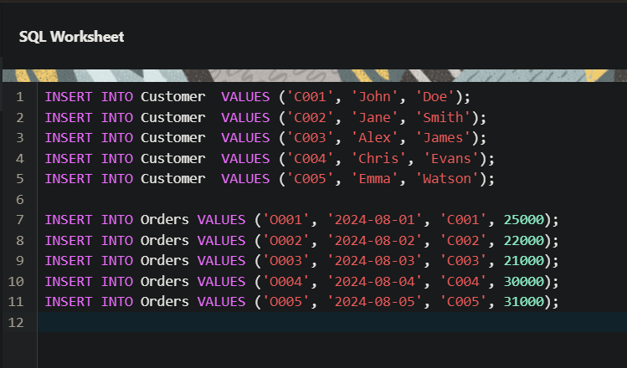

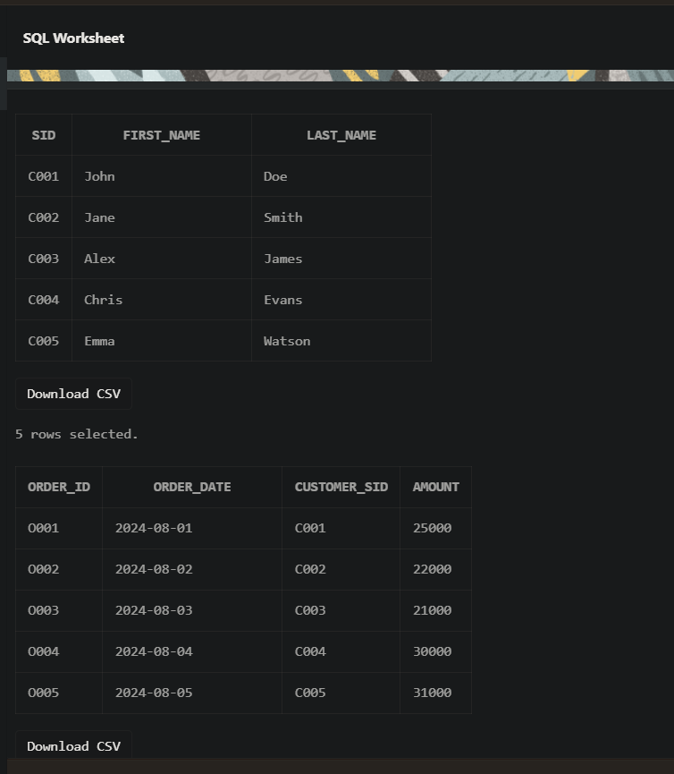

**EXERCISE 3**

**AIM:** Customer SID column in the ORDERS table is a foreign key pointing to the SID column in the CUSTOMER table.

**Output:**

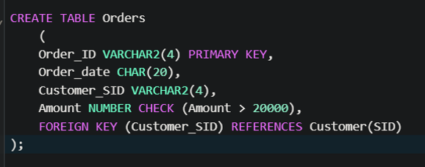

**EXERCISE 4**

**AIM:** List the details of the customers along with the amount.

**Output:**

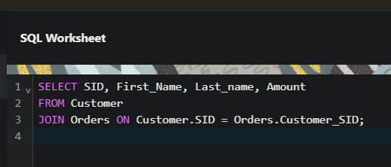

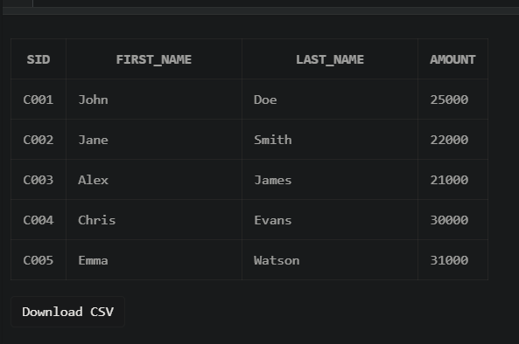

**EXERCISE 5**

**AIM:** List the customers whose names end with “s”.

**Output:**

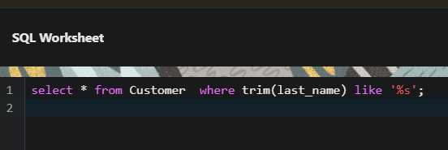

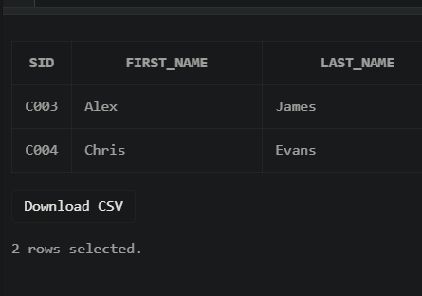

**EXERCISE 6**

**AIM:** List the orders where amount is between 21000 and 30000

**Output:**

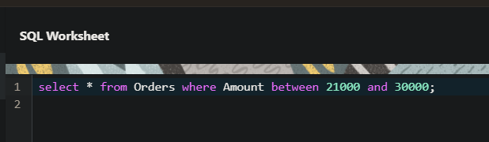

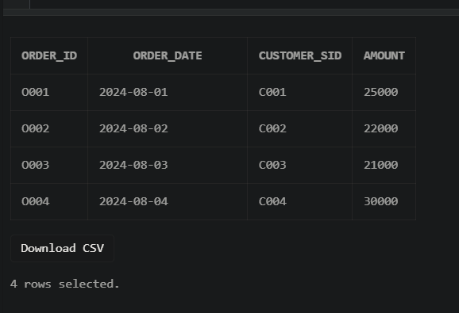

**EXERCISE 7**

**AIM:** List the orders where amount is increased by 500 and replace with name “new amount”**.**

**Output:**

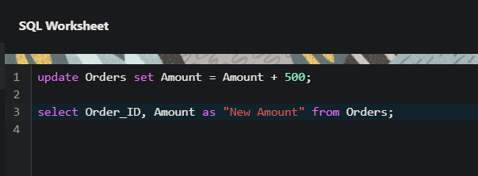

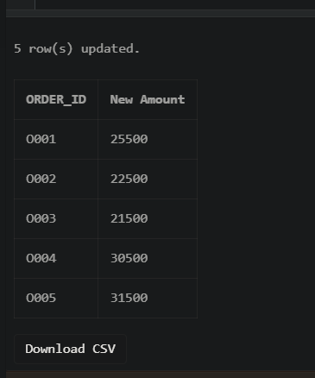

**EXERCISE 8**

**AIM:** Display the order_id and total amount of orders.

**Output:**

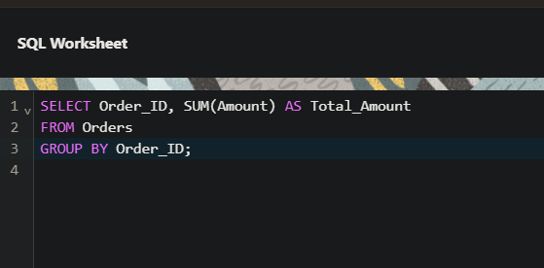

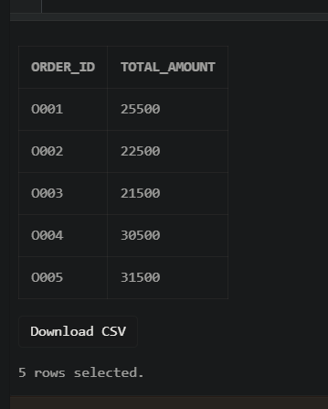

**EXERCISE 9**

**AIM:** Calculate the total amount of orders that has more than 15000.

**Output:**

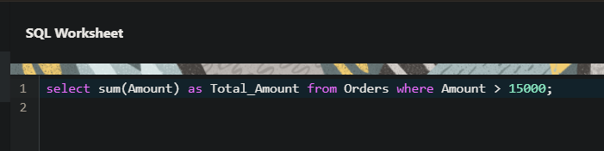

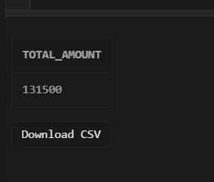

**EXERCISE 10**

**AIM:** Display all the string functions used in SQL.

**Output:**

SELECT

LOWER('ORACLE') AS "Lowercase", -- Converts string to lowercase

UPPER('oracle') AS "Uppercase", -- Converts string to uppercase

SUBSTR('ORACLE', 2, 3) AS "Substring", -- Extracts substring

LENGTH('ORACLE') AS "Length”, -- Returns length of string

INSTR('ORACLE', 'A') AS "Position", -- Returns position of a character

LPAD('123', 5, '0') AS "Left Padding", -- Pads a string on the left

RPAD('123', 5, '0') AS "Right Padding",-- Pads a string on the right

TRIM('O' FROM 'ORACLE') AS "Trimmed" -- Trims a specified character

FROM DUAL;

**EXERCISE 11**

**AIM:** Create the following tables.

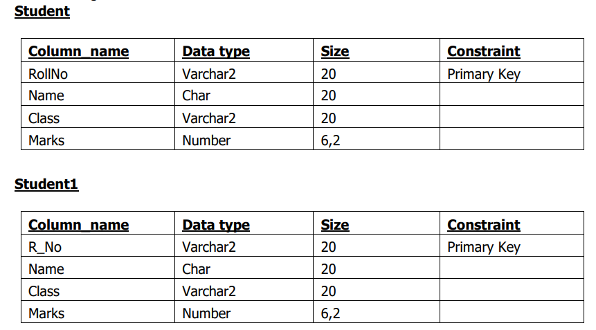

**Output:**

